**FITFLEX**

**Project Design Phase II**

**Data Flow Diagram & User Stories**

|  |  |
| --- | --- |
| Date | 11/03/2025 |
| Team ID | ID-151215 |
| Project Name | Fit Flex |
| Maximum Marks | 4 Marks |

**Data Flow Diagrams:**

A Data Flow Diagram (DFD) is a traditional visual representation of the information flows within a system. A neat and clear DFD can depict the right amount of the system requirement graphically. It shows how data enters and leaves the system, what changes the

information, and where data is stored.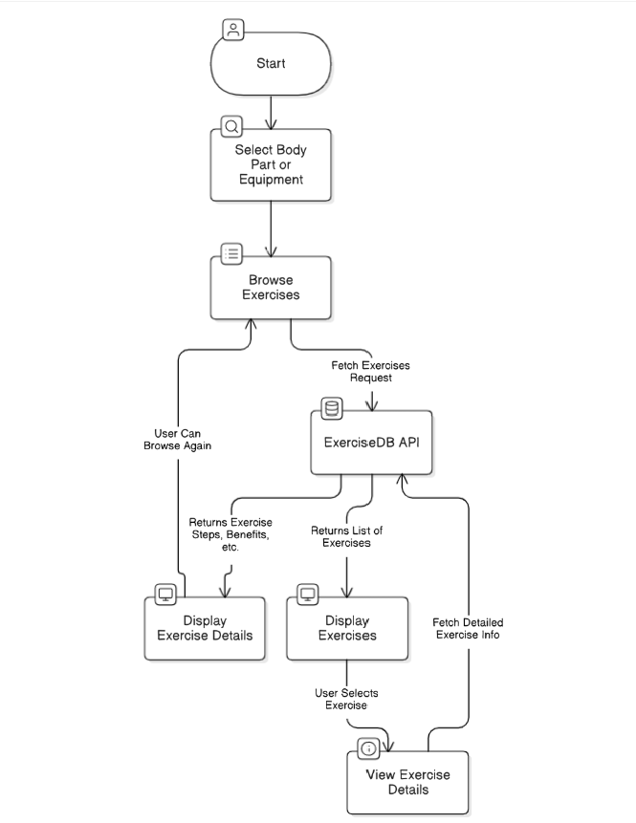

1. The User selects a body part or equipment.
2. The request is sent to Browse Exercises, which fetches relevant data from ExerciseDB API.
3. The API returns a list of exercises, which is displayed to the User.
4. The User selects a specific exercise, triggering the View Exercise Details process.
5. The ExerciseDB API provides detailed exercise information.
6. The app displays the details, and the User can either browse more exercises or select another one.

**User Stories:**

| **User Type** | **User Story Number** | **User Story / Task** | **Acceptance criteria** | **Priority** | **Release** |
| --- | --- | --- | --- | --- | --- |
| Customer (Web User) | USN-1 | As a User, I can browse exercises by selecting a body part. | I can see a list of exercises related to the selected body parts. | High | Sprint-1 |
| Customer (Web User) | USN-2 | As a user, I can browse exercise by selecting equipment. | I can see a list of exercises related to the selected equipment. | High | Sprint-1 |
| Customer (Web User) | USN-3 | As a user, I view detailed explanations about exercise. | I can see exercise images, steps and target muscles | High | Sprint-1 |
| Customer (Web User) | USN-4 | As a user, I can see related Youtube videos. | I can navigate to the related videos on Youtube. | Low | Sprint-2 |
| Customer (Web User) | USN-5 | As a user, I can easily navigate to the home page. | I can click the home button and return to the home page. | High | Sprint-1 |